**Sensitivity testing of the Char-Analysis software package with synthetic charcoal datasets**

***Motivation***

Long-term fire history research utilizing sedimentary charcoal profiles is an important method for paleoecologists to determine past changes in fire activity. Sedimentary paleoecology records vary widely in length and temporal resolution, ranging from covering a small portion of the Holocene to spanning all the way back into the late Pleistocene. In the past two decades a handful of analytical tools have been developed to investigate sedimentary charcoal records to attempt to make more specific statements about fire return intervals (FRIs) (Higuera et al., 2010, Kelly et al., 2011). Some of the commonly used programs are Charster, Charcoal Analysis Programs (CHAPS), and most recently CharAnalysis (Gavin et al., 2006, Anderson et al., 2008, Higuera, 2009). My research project for EES 599 aims to perform sensitivity testing on the Char Analysis program to determine the limitations associated with the program. I specifically am looking at the relationship between sedimentation rates, sampling intervals, and the FRI of known synthetic datasets to understand what types of sedimentary charcoal records can be analyzed appropriately.

***Background***

CharAnalysis is a program designed by Phil Higuera that analyzes sedimentary charcoal records to estimate charcoal peaks and reconstruct local fire history (Higuera, 2009). This program is based off of previous tools like Charster and CHAPS, which separate charcoal records into low and high frequency signals, ultimately aiming to identify the low frequency events as charcoal peaks and specific fire events (Gavin et al., 2006, Anderson et al., 2008). The CharAnalysis program adds to these prior tools by allowing the used to define a locally defined charcoal threshold (Higuera, 2009). The program allows the user to choose between a variety of parameters. The user is also able to specific zones within the charcoal record which can separate the CharAnalysis to analyze zones with different characteristics. Higuera et al. (2010) examined the usability of this tool with the use of a locally defined threshold, rather than a globally defined threshold. The authors suggested that the application of the locally defined threshold is much more adaptable to variability within the charcoal record. This research concluded that three major considerations must be taken into account when using CharAnalysis.

1. Users should be extra careful when examining records with low charcoal input and low variability.
2. Users must consider sample resolution as a cause in change of variability. It is advised to try to keep sampling resolution relatively stable.
3. Low charcoal count sections must be analyzed with caution, as high-intensity fires may not produce enough of a charcoal signal to be interpreted easily.

My project aims to address part of the 2nd consideration made by Higuera et al. (2010), in regard to my thesis project. For my thesis work I will be reconstructing a long-term fire history of the Padul peat bog in southeastern Spain. This record is interesting because it covers the Holocene, and reaches back to the late Pleistocene. This record covers the last ~45 ka within 6.5 m of sediment. When writing my thesis proposal I considered the possibility of using CharAnalysis for my charcoal data. My sensitivity testing aims to determine whether or not CharAnalysis can be used appropriately for my analysis.

***Dataset***

The dataset that I will be constructing for sensitivity testing will be based off of the charcoal data that I have collected for my research. The sampling resolution for my project is set at 1 cm intervals, and I am counting charcoal particles for 1 cm3 subsamples for the first 6.5 m of sediment. This first 6.5 m of sediment covers the last ~45 ka. The data I have collected so far suggest that charcoal counts are very high during MIS 1 and 3, and rather low during MIS 2. The initial dataset I created had a FRI set to 50 yr, and each fire was set to burn 50-90% of the catchment. I set the number of charcoal particles produced from these fire events to be set between 250 and 750 pieces of charcoal per fire event. The amount of charcoal was set to decay by ½ each year after a fire event. This step was taken to represent delayed deposition which has been shown to occur up to several years after a fire event (Whitlock and Anderson, 2003). I then needed to turn this 50 ka record into a sediment record that simulated the process of summing the charcoal particles into a subsample. I took this 50 ka record and summed it into 500 subsamples, where the record contained a steady sedimentation rate. Therefore, each subsample contains 100 yrs of charcoal. I wanted there to be a large amount of variability in the record to most realistically simulate natural conditions.

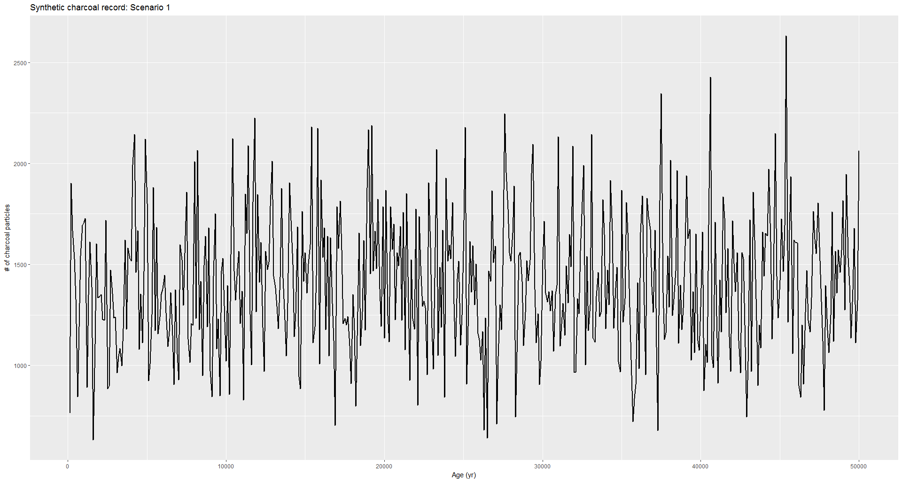

**Figure 1**. Raw charcoal data for scenario 1, with a FRI of 50 yrs.

After this initial dataset was constructed I used the exact same procedure to create more datasets, but changed the known FRI to see how the results differed each time. I also was able to use Charles Mogen’s charcoal data from his Crater Lake to see how CharAnalysis would look for a real record.

***Methodology***

Originally I thought that I would be able to do this through an R version of the CharAnalysis that I found on GitHub. After further inspection, the R version of the program had not been completed, forcing me to use Mat lab. The program requires that the charcoal data be organized into a specific excel sheet template.



**Figure 2**. Char Analysis charcoal data spreadsheet template required for CharAnalysis.

The data which was created in R was then written into a csv file, and then copied into the excel template. The CharAnalysis excel template has three tabs, one contains the organized data, one with the parameter selection, and one empty tab where the results are placed. For the first four scenarios, the all of the data was organized in the same way, but the FRI was set to 50, 100, 500, 750, 1000, and 1500 yrs to determine the usability of CharAnalysis. For each of these four scenarios, there were no zone divisions, i.e. the record was analyzed continuously for the entire 50 ka. The record was interpolated to the median sample resolution, which is 100 yrs. I chose to not transform the record before analysis. The estimated low-frequency CHAR (background charcoal) was determined by using a moving median, and the record was smoothed over 500 yrs for estimating the low-frequency CHAR. The high-frequency component (peaks) was determined by calculating the residuals, and the threshold method for peak identification used a locally defined by a Gaussian 95th percentile cutoff of a noise distribution. This was chosen because in these scenarios the FRI and sedimentation rate are constant throughout the entire record.

***Results/Discussion***

The initial scenario of a known FRI of 50 yrs returned a mean estimated FRI of 381 yrs.

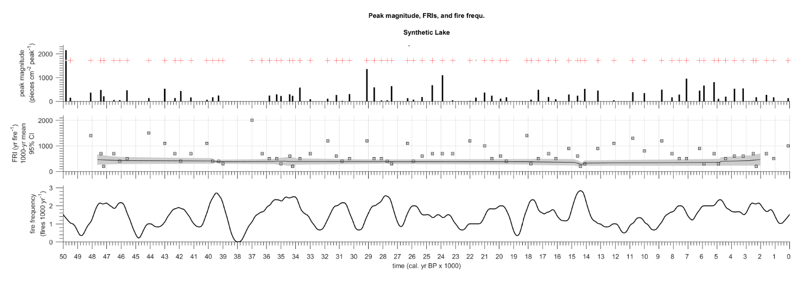

**Figure 3**. Peak detection (top panel), estimated FRI (middle panel), and fire frequency per 1000 yr (bottom panel) for the known 50 yr FRI synthetic dataset. The middle panel shows the estimated FRI, with a mean of 677 yrs.

This presents the issue of a fire interval that is not captured within the temporal resolution of the record. Due to these initial results I then increased the FRI to 100 yrs to determine whether CharAnalysis, keeping the rest of the parameters the same, the analysis determined FRI of 415 yrs.

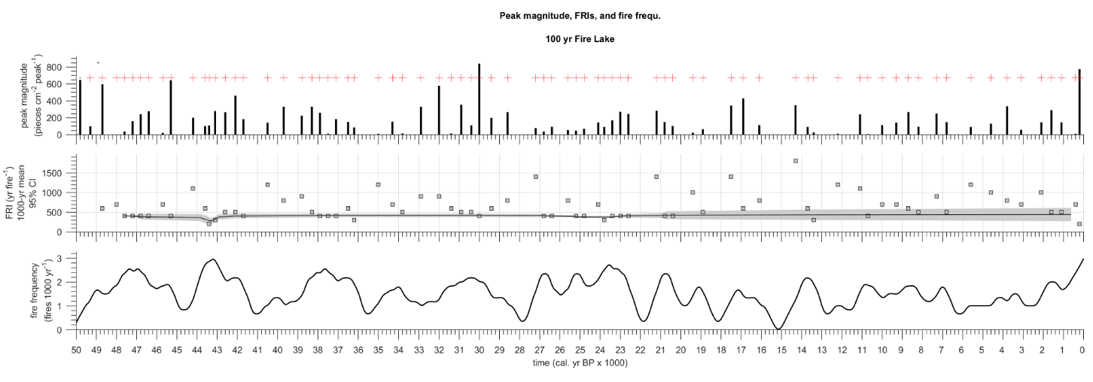

**Figure 4**. Peak detection (top panel), estimated FRI (middle panel), and fire frequency per 1000 yr (bottom panel) for the known 100 yr FRI dataset. The middle panel shows the estimated FRI, with a mean of 415 yrs.

The synthetic data with the known 500 yrs FRI returned an estimated FRI of 450 yrs.

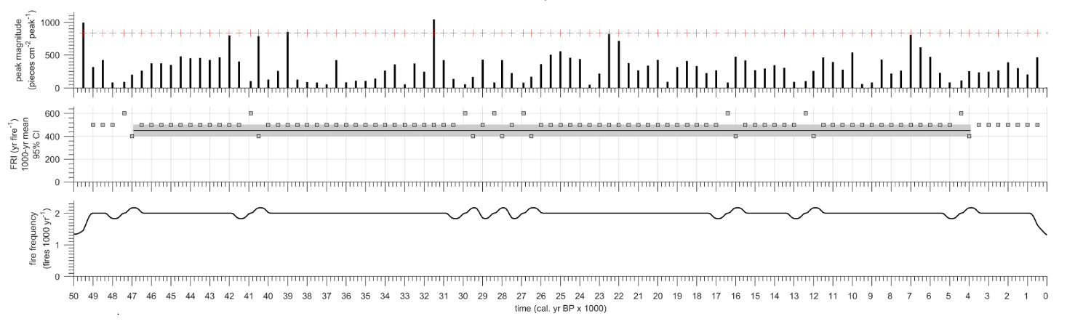

**Figure 5**. Peak detection (top panel), estimated FRI (middle panel), and fire frequency per 1000 yr (bottom panel) for the known 500 yr FRI synthetic dataset. The middle panel shows the estimated FRI, with a mean of 450 yrs.

When the known synthetic FRI is set to 750 yrs, CharAnalysis returns an estimated fire interval of 1500 yrs.

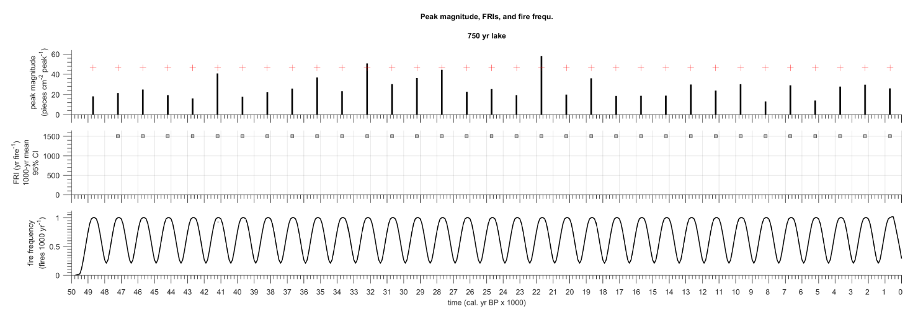

**Figure 6**. Peak detection (top panel), estimated FRI (middle panel), and fire frequency per 1000 yr (bottom panel) for the known 750 yr FRI synthetic dataset. The middle panel shows the estimated FRI, with a mean of 1500 yrs.

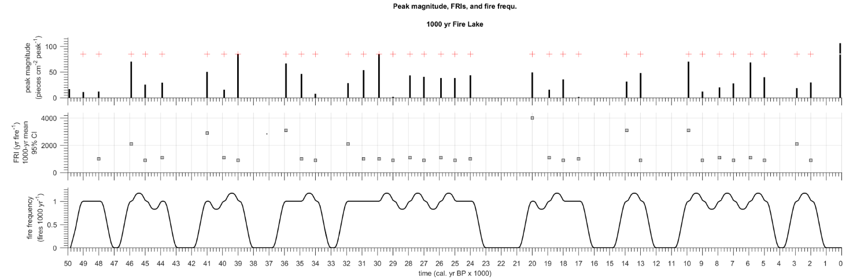

**Figure 7**. Peak detection (top panel), estimated FRI (middle panel), and fire frequency per 1000 yr (bottom panel) for the known 1000 yr FRI synthetic dataset. The middle panel shows the estimated FRI, with a mean of 1425 yrs.

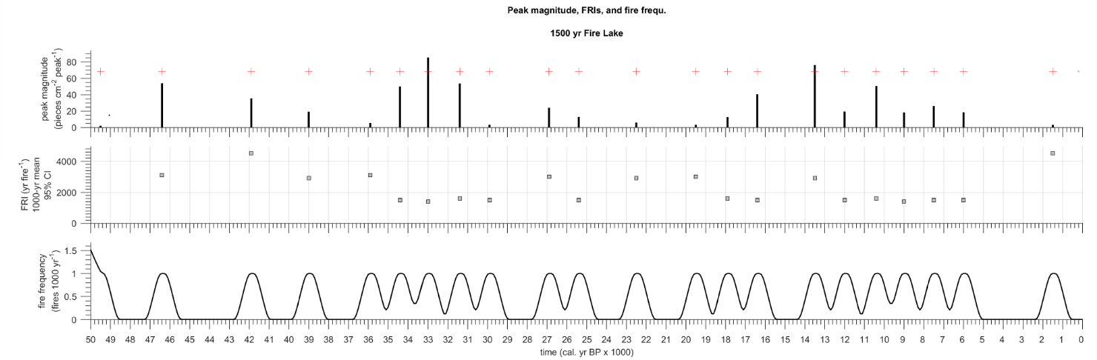

**Figure 8**. Peak detection (top panel), estimated FRI (middle panel), and fire frequency per 1000 yr (bottom panel) for the known 1500 yr FRI synthetic dataset. The middle panel shows the estimated FRI, with a mean of 2300 yrs.

The most accurate scenario for estimating the FRI is shown in Figure 4, where the known FRI is set to 500 yrs, and the sampling interval is 100 yr / cm.

***Conclusion***

The results suggest that estimating the FRI is difficult, and the difference between the temporal resolution record of the record and the real FRI is sensitive. It is clear that the use of CharAnalysis will not be appropriate for investigating the Padul record as a whole. However it could be beneficial to look at the Holocene, MIS 3 and MIS 5 specifically. The usability of the program will become more apparent as I fill in more charcoal data throughout the record. The difficulty associated with the Padul record is the fact that it is indeed a large bog at the base of the Sierra Nevada, and the current results suggest that the background charcoal values are high. If the record for the Holocene shows variability for the Holocene, MIS 3, and MIS 5, I plan to use CharAnalysis to look at these segments of the record.

On a final note, I plan to look into this program more in the future and tweak more of the parameters within the program itself. This sensitivity testing only focused on sedimentation rate and FRI, but did not test the differences in pre-treatment, smoothing, and peak analysis methods.

**References**

Anderson, R.S., Allen, C.D., Toney, J.L., Jass, R.B., Bair, A.N., 2008. Holocene vegetation and fire regimes in subalpine and mixed conifer forests, southern Rocky Mountains, USA. International Journal of Wildland Fire 17, 96-114.

Gavin, D.G., Hu, F.S., Lertman, K., Corbett, P., 2006. Weak climatic control of stand-scale fire history during the late Holocene. Ecology 87 (7), 1722-1732.

Higuera, P.E., 2009. *CharAnalysis* 0.9: Diagnostic and analytical tools for sediment-charcoal analysis. User Guide.

Higuera, P.E., Gavin, D.G., Bartlein, P.J., Hallett, D.J., 2010. Peak detection in sediment–charcoal records: impacts of alternative data analysis methods on fire-history interpretations. International Journal of Wildland Fire 19 (8), 996-1014.

Kelly, R.F., Higuera, P.E., Barrett, C.M., Hu, F.S., 2011. A signal-to-noise index to quantify the potential for peak detection in sediment–charcoal records. Quaternary Research 75, 11-17.

Whitlock, C., Anderson, R.S., 2003. Fire History Reconstructions Based on Sediment Records from Lakes and Wetlands. *Fire and Climatic Change in Temperate Ecosystems of the Western Americas.* Springer, New York. pp. 3-31.

